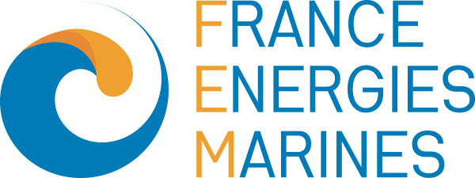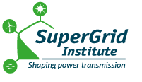
The RHODÉ consortium launches a major R&D project for a floating HVDC electrical connection for deep-water offshore wind farms

PRESS RELEASE

- Chantiers de l’Atlantique, France Energies Marines, Fondation OPEN‑C, GE Vernova, Nexans, RTE and SuperGrid Institute are combining their expertise to prepare future high‑power, floating, high‑voltage direct current (HVDC) grid connections.
- The RHODÉ project aims to develop and test the key technological building blocks (transformer, gas insulated substation, offshore AC/DC converter station, dynamic HVDC cable) required for a first high-power floating connection.
- The project will deliver two floating substation designs, rated at 320 kV and 525 kV respectively.
- The project will help to establish a world-class French industrial sector for offshore wind power.

Nantes, 19 May 2026 – Chantiers de l’Atlantique, France Energies Marines, Fondation OPEN‑C, GE Vernova, Nexans, RTE and SuperGrid Institute announce the launch of RHODÉ (Raccordement HVDC Offshore Distant Électrique), a collaborative R&D project dedicated to developing future high‑voltage direct current (HVDC) floating electrical connections for large‑scale offshore wind farms installed in deep waters, far from the coast.
A project at the heart of France’s offshore wind ambitions

The largescale deployment of offshore wind, in France as well as internationally, is potentially leading to the development of sites located at depths greater than 100 metres and several tens of kilometres from the coastline. Under these conditions, traditional solutions with fixed bottom substations may reach their technical and economic limits. Floating electrical substations are emerging as an alternative or additional solution to enable the continued development of offshore wind while controlling costs, environmental impacts and coexistence with other maritime activities.

In this context, RHODÉ forms the missing link between research projects already underway and the industrial realisation phase of the first 320 kV or 525 kV floating HVDC connections, envisaged from 2040 onwards.

Two major goals: technology and industrial sector

RHODÉ pursues two strategic objectives:

- To develop and validate the key technological building blocks of a high‑voltage floating electrical connection (320 kV or 525 kV) in high‑voltage direct current (HVDC);
- To pave the way for the emergence of a French industrial sector specialising in high‑power offshore floating electrical connections, that is competitive in both French and export markets.

A structured program of R&D, testing and demonstration

The RHODÉ project is organised into several work packages covering the entire value chain, from defining use cases and technical specifications through to the first offshore trials. It combines advanced design work and numerical modelling of the floating HVDC substation and its components, laboratory test campaigns, environmental impact studies on the floating substation in the marine environment, hydrodynamic basin tests on reduced scale models, as well as unit tests at sea to validate the operational feasibility of installation, maintenance and decommissioning concepts.

A consortium covering the full range of skills along the value chain
To address all the challenges, from maritime aspects to the transmission grid, including environment, HVDC conversion and submarine cables, RHODÉ brings together seven partners with complementary expertise:

- Chantiers de l’Atlantique: expertise in the design, construction, integration of various systems and commissioning of offshore substation (topside and foundation).
- France Energies Marines: expertise in the design of moorings, digital twins, decision-support tools for the operation of offshore substations and environmental impact assessment.
- Fondation OPEN-C: management of the five offshore test sites in France and expertise in hosting prototypes at sea (infrastructure, including grid connection, operations and maritime safety, environmental monitoring).
- GE Vernova: know‑how in the design and construction of AC/DC substations, transformers, gas‑insulated substations and associated control and protection systems;
- Nexans: expertise in the design, testing, qualification, manufacturing and installation of dynamic HVDC subsea cable systems and high-voltage direct current (HVDC) subsea cables.
- RTE: Development, maintenance and operation of the public electricity transmission network.
- SuperGrid Institute: Expertise in the development of SF6-free insulation solutions, the simulation of dielectric stresses associated with the design of HVDC metal-enclosed substations and their interfaces with floating substation components, and the performance of specific dielectric and power tests on this equipment.

The RHODÉ project was awarded a grant of 16 M€.
This project is funded by the French State as part of France 2030 operated by ADEME.
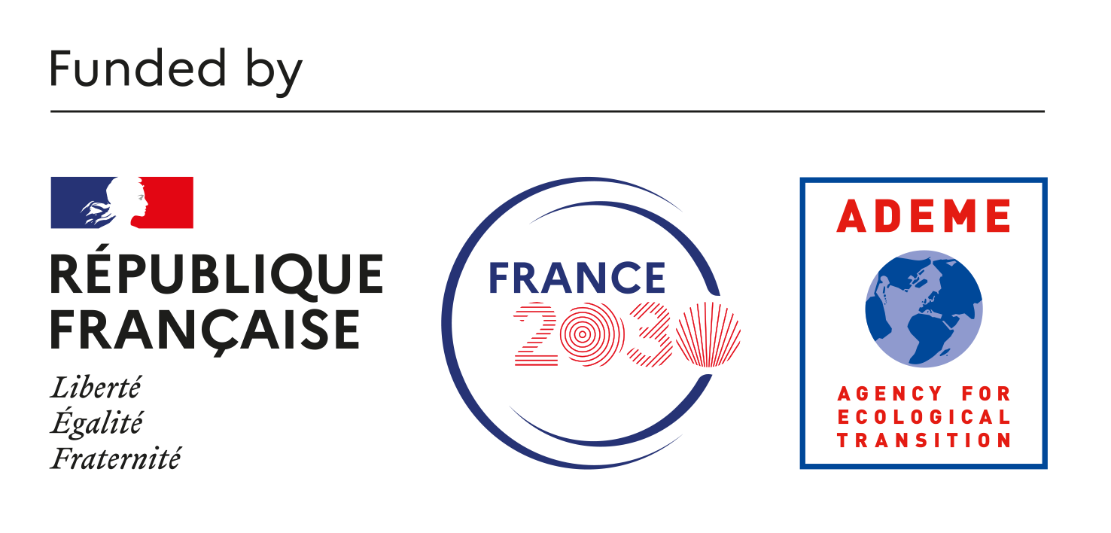

About the RHODÉ project
RHODÉ – Raccordement HVDC Offshore Distant Électrique – is a collaborative project that aims, by 2040, to prepare the commissioning of the first 320 kV or 525 kV floating HVDC connections for offshore wind power in France. By developing and validating the necessary technological building blocks (floating HVDC substation, dynamic HVDC cable, innovative equipment) and preparing the industrial sector, RHODÉ contributes to the energy and industrial sovereignty of France and Europe, while supporting the transition to a low‑carbon power system.

About Chantiers de l’Atlantique
Thanks to the expertise of its teams and its network of subcontractors, associated with its first-rate industrial facilities, Chantiers de l'Atlantique is a key leader in the fields of design, integration, testing and turnkey delivery of cruise ships, naval vessels, electrical substations for offshore wind farms and services to the fleets. The company is at the core of the challenges of tomorrow, designing and building today ships whose environmental performance exceeds the most drastic standards, as well as equipment for offshore wind power that make it a major player in the energy transition.

Contact: christine.romieux@chantiers-atlantique.com

About France Energies Marines
France Energies Marines is the French research and innovation centre dedicated to offshore wind. Its mission is to remove the obstacles faced by the offshore wind energy sector.
Backed by the French government and supported by a multidisciplinary team of more than 90 staff, a network of international experts and unique infrastructures, the Institute conducts multi-partner research projects guided by excellence.
The results are transferred to the industry in the form of research and expertise services, operating licences, know-how transfer and participation in expert committees and networks.
These activities are structured around four complementary departments: Wind & Ocean Dynamics, Systems & Performance, Wildlife & Interactions, Ecosystem & Society. More information at: https://www.france-energies-marines.org/en

Contact:
Mélusine Gaillard – melusine.gaillard@ite-fem.org - T. +33 (0)2 98 49 98 27

About Fondation OPEN-C
Fondation OPEN-C coordinates, develops, and manages France’s five offshore testing sites for floating wind and Marine Renewable Energies (MRE), providing infrastructures dedicated to industrial development, research, and innovation under real-world conditions. Offshore testing validates tomorrow’s energy solutions and accelerates their deployment, while measuring performance and environmental impact. As a public-interest organization, the Foundation is an essential tool to mitigate risks, reduce costs, and accelerate the time-to-market of offshore innovations. Building on the combined strength of its multidisciplinary teams and sites, Fondation OPEN-C serves as a strategic lever to advance the energy transition at sea, supporting the development of Offshore Renewable Energies (ORE) in France and across Europe.

Contact:
Sandrine JAMET, presse@fondation-open-c.org, 06 84 19 74 72

About GE Vernova
is a planned, purpose-built global energy company that includes Power, Wind, and Electrification segments and is supported by its accelerator businesses of Advanced Research, Consulting Services, and Financial Services. Building on over 130 years of experience tackling the world’s challenges, GE Vernova is uniquely positioned to help lead the energy transition by continuing to electrify the world while simultaneously working to decarbonize it. GE Vernova helps customers power economies and deliver electricity that is vital to health, safety, security, and improved quality of life. GE Vernova is headquartered in Cambridge, Massachusetts, U.S., with more than 80,000 employees across 100+ countries.

Contact: ann.engdahl@gevernova.com

About Nexans
Nexans is the global pure player in sustainable electrification, building the essential systems that power the world’s transition to a connected, resilient, and low-carbon future. From offshore and onshore renewable energies to smart cities and homes, Nexans designs and delivers advanced cable solutions, accessories and services that electrify progress safely, efficiently, and sustainably.
With over 140 years of history, through three core businesses: PWR Transmission, PWR Grid, and PWR Connect, Nexans blends deep industry expertise with cutting-edge innovation to accelerate the energy transition and better meet its customers' needs. Its unique E3 model, focused on Environment, Economy and Engagement, drives every action, aligning performance with purpose.
Nexans operates in 41 countries with 25,700 people and generated €6.1 billion in standard sales in 2025. Nexans is committed to Net-Zero emissions by 2050 aligned with the Science Based Targets initiative (SBTi) and expanding energy access through the Fondation Nexans.
Nexans is listed on Euronext Paris, Compartment A.
www.nexans.com | #ElectrifyTheFuture

Contact:
Berkeley PR - nexans_uk@berkeleypr.com
Emmanuelle Guy - emmanuelle.guy@nexans.com

About RTE
RTE is the transmission system operator for electricity in France. As part of its public service mission, RTE guarantees, every day and always, the delivery of electricity throughout the country and ensures, in real time, the management of power flows and the balance between generation and consumption. To connect regions and industries to electricity production, RTE deploys, onshore and offshore, infrastructures that are essential to the decarbonisation of our economy and the energy transition.
Faced with climate, economic and environmental challenges that call for far‑reaching transformations, RTE operates and develops more than 106,000 kilometres of high and extra‑high‑voltage power lines. This network, the most extensive in Europe, includes 37 interconnections with neighbouring countries and around 50 cross‑border links. Thanks to the commitment of its 10,000 employees across the country, RTE works every day to make the electricity grid the driving force behind a decarbonised France.

Contact:
RTE press service : rte-presse@rte-france.com –
Lolita Tcaci – 06 32 51 29 04
Charlotte Brouard - 06 71 36 55 11
For further information: www.rte-france.com
To contact RTE | RTE

About SuperGrid Institute
SuperGrid Institute is an independent private company specialising in high and medium-voltage direct current (HVDC & MVDC) systems and technologies – key components for future energy networks. Based in Villeurbanne (Lyon - France), SuperGrid Institute’s work actively contributes to the energy transition by removing technical barriers to the deployment of future electricity grids and the large-scale integration of renewable energy. The company is a member of the FIT (French Institutes of Technology) association, which brings together 15 French institutes, technology research institutes (IRTs) and institutes for energy transition (ITEs) that share the same core principles regarding multi-partner public-private research.

Contact:
Anne-Soizic Ranchere, Partnerships, Business Development and Communications Director
anne-soizic.ranchere@supergrid-institute.com - 07 60 77 32 31

