Press release, the 23rd of March 2026 January 2025
The HVDC-WISE project reaches the final year

Europe is deploying record amounts of renewable energy sources, while at the same time the grid is being challenged by tighter supply margins, rising cross border electric power flows, and a variety of extreme events. Keeping energy affordable and the lights on increasingly depends on a power system that can move large amounts of clean power quickly and reliably and recover fast when disruptions hit. The widespread use of HVDC technology in point-to-point and multi-terminal systems is being adopted as a solution to flexible large-scale transmission needs.

That’s the challenge the HVDC-WISE project has been tackling. The project is helping develop practical planning methods and tools for widespread hybrid AC/DC systems that grid operators and decisionmakers can use to build a more reliable and resilient European power system.
Currently in its final year, HVDC-WISE has delivered practical ways to help Europe move more clean electric energy where it’s needed—more reliably, and with faster recovery when disruptions occur. The project has worked with grid operators to map out realistic future scenarios for the European and Great Britain power systems and then developed usable planning approaches and tested solutions on these future scenarios. It has produced improved methods for running and coordinating grid studies across a range of tools so experts can assess options more quickly and consistently. The project also developed new planning analyses that look not only at common contingencies (reliability analysis), but also at how the system holds up during major events and how quickly it can bounce back (resilience analysis). To speed up progress beyond the project itself, HVDC-WISE has also made open-access deliverables and open-source modelling and software releases available from the project, enabling more organisations to learn from the work and apply it in their own planning and decision making.
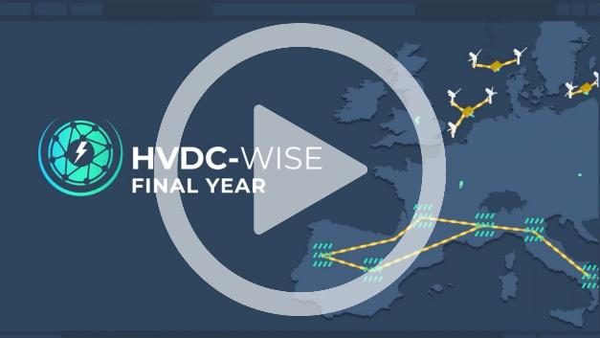

As Juan-Carlos Gonzalez, Project Coordinator from SuperGrid Institute, explains, the strength of HVDC-WISE lies in the way diverse expertise is brought together to tackle real-world challenges:
“What makes HVDC-WISE truly unique is the complementarity of its partners: transmission system operators, academia and R&D centres working together on real system challenges. This collaboration has enabled us to develop practical methodologies, interoperable tools, and validated control and protection concepts for hybrid AC/DC grids. Through large-scale use cases in Europe and Great Britain, we are demonstrating how HVDC technologies can strengthen reliability and resilience. Our final deliverables aim to translate this work into concrete guidance that supports a faster and more secure expansion of HVDC across Europe.”
In its final year, HVDC-WISE is now pressure testing these methods and tools on three large scale demonstration use cases: a mainland European case, a GB-based case, and a multipurpose offshore HVDC grid linking the EU and GB. Validation studies focused on protection and control help ensure that operational techniques developed during the project perform under realistic operating conditions.
HVDC-WISE will conclude by translating its findings into actionable recommendations for industry and policymakers. Final outputs will include guidance to improve model sharing and interoperability, practical approaches to embedding resilience into grid planning, suggested updates to existing codes and regulations, and a technology roadmap to help accelerate HVDC deployment where it delivers the greatest benefit.
Explore the HVDC-WISE resources page, download public deliverables, and access open-source toolboxes for modelling and techno-economic analysis. Subscribe to our newsletter and follow us on LinkedIn to stay informed about final dissemination events.
Together, we can make Europe’s future HVDC-enabled grid reliable, resilient, and ready.
Learn more: https://hvdc-wise.eu/

Press contact
Juan-Carlos Gonzalez, Project Coordinator, SuperGrid Institute
+33 (0)7 61 69 58 67 - juan-carlos.gonzalez@supergrid-institute.com

Karly Korte, EPRI Europe Communications Associate
kkorte@epri.com


ABOUT SUPERGRID INSTITUTE:
SuperGrid Institute is the coordinator of the HVDC WISE project. It is an independent, privately-owned company with expertise in high and medium voltage direct current (HVDC & MVDC) systems and technologies - key components for future energy networks.

